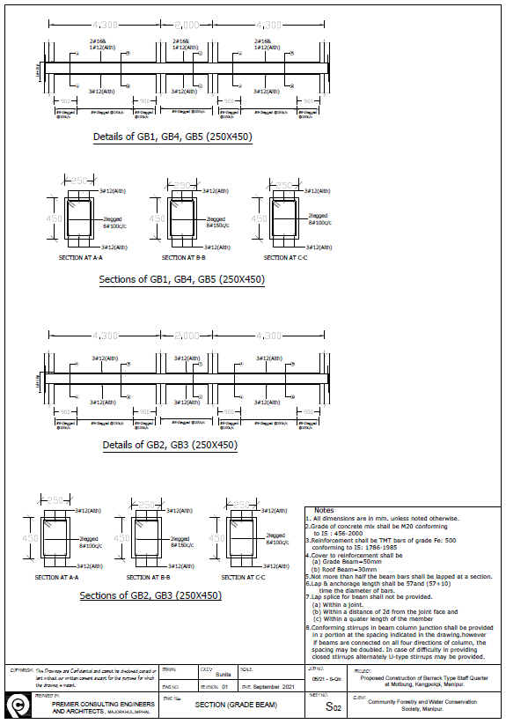

GRADE BEAM SECTION 1

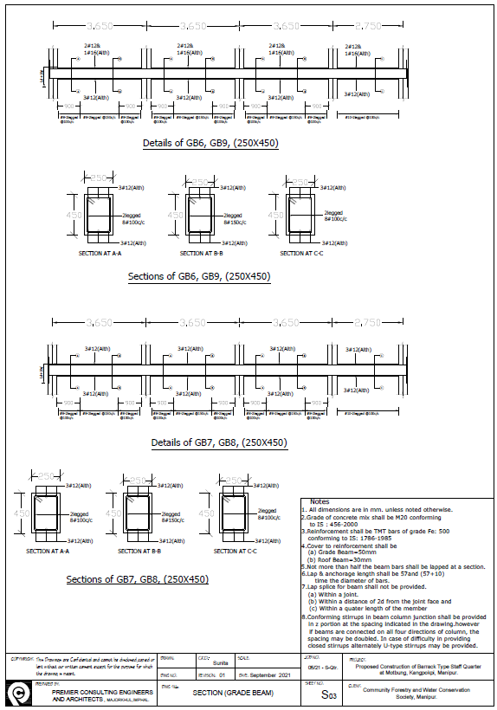

GRADE BEAM SECTION 2

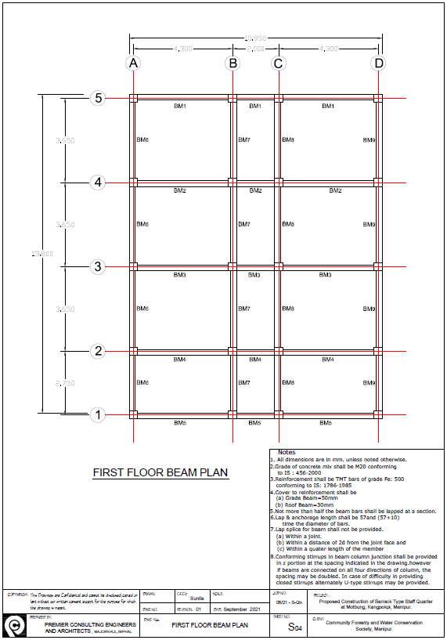

FIRST FLOOR BEAM PLAN

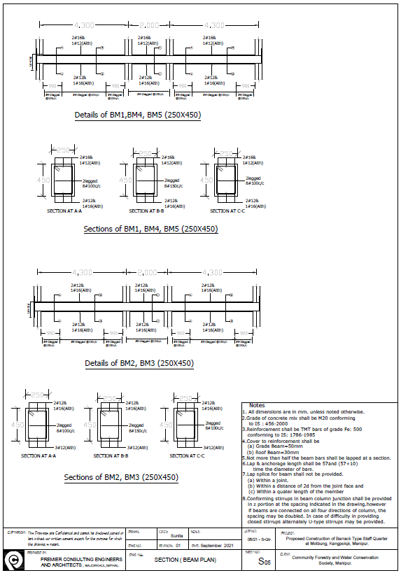

FIRST FLOOR BEAM SECTION 1

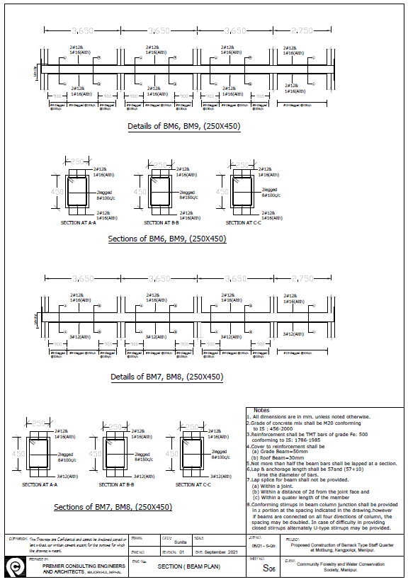

FIRST FLOOR BEAM SECTION 2

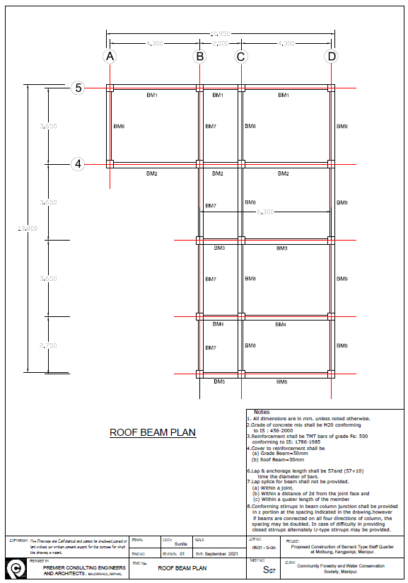

ROOF BEAM PLAN

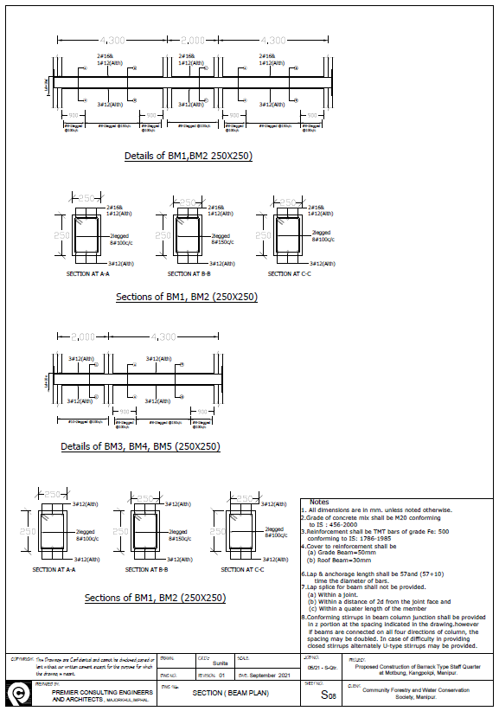

ROOF BEAM SECTION 1

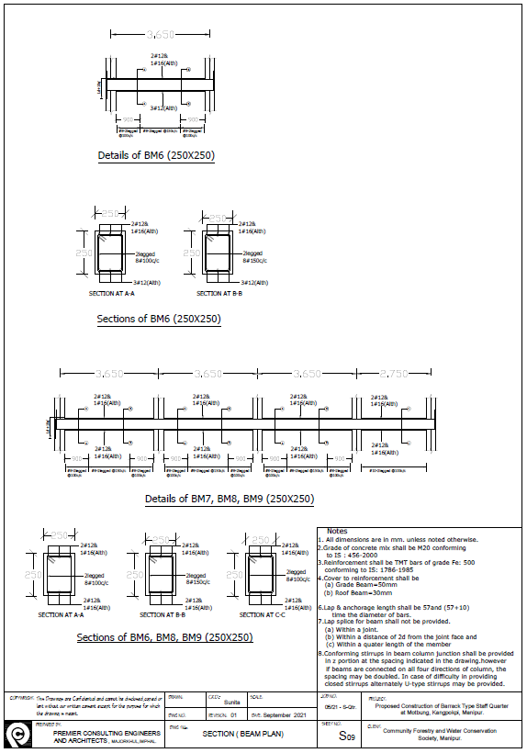

ROOF BEAM SECTION 2

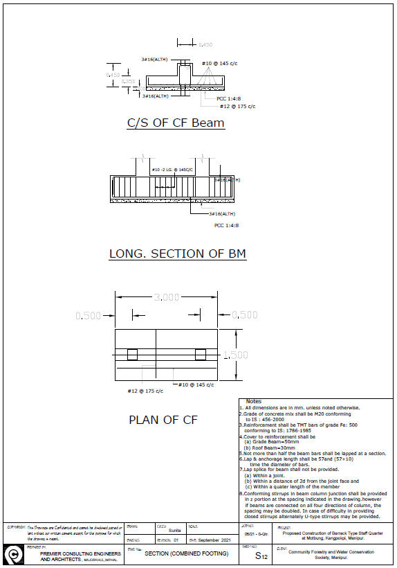

SECTION COMBINED FOOTING