1. Drawings

*\*\*Disclaimer\*\* - Final Approved Drawings and any clarification which is required can be obtained from the office of Project Director, Community Forestry and Water Conservation Society*

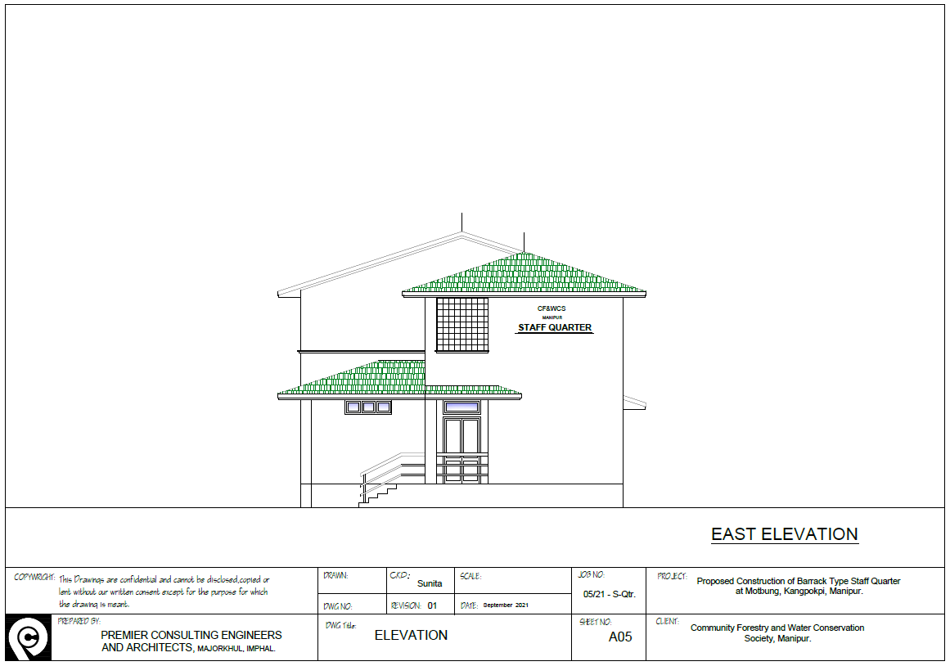

EAST ELEVATION

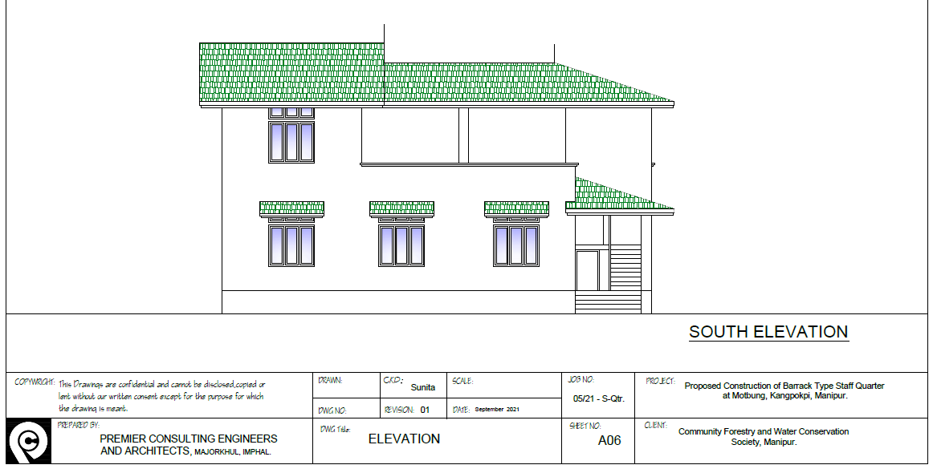

SOUTH ELEVATION

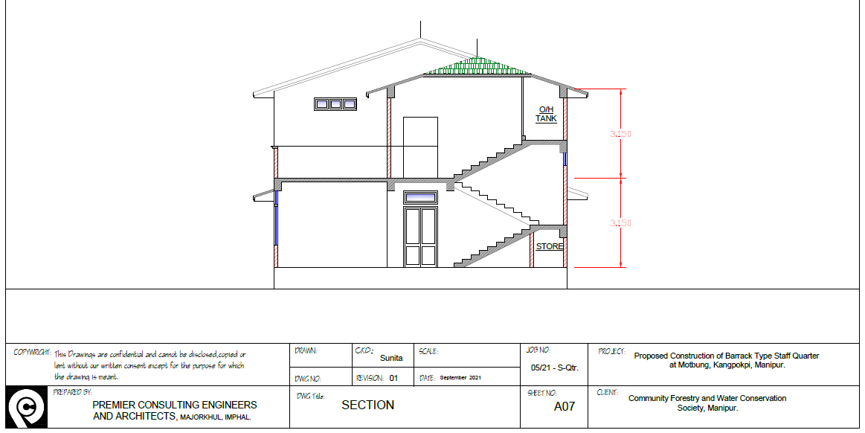

SECTION PLAN

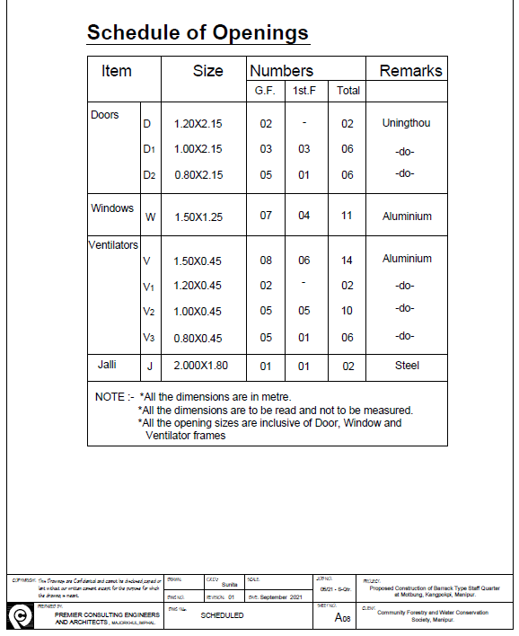

SCHEDULE OF OPENINGS

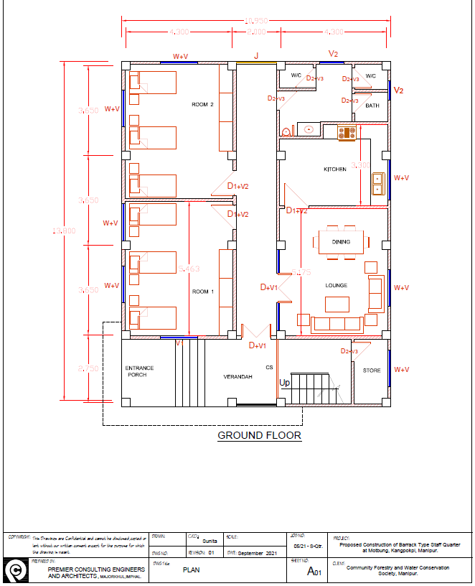

GROUND FLOOR PLAN

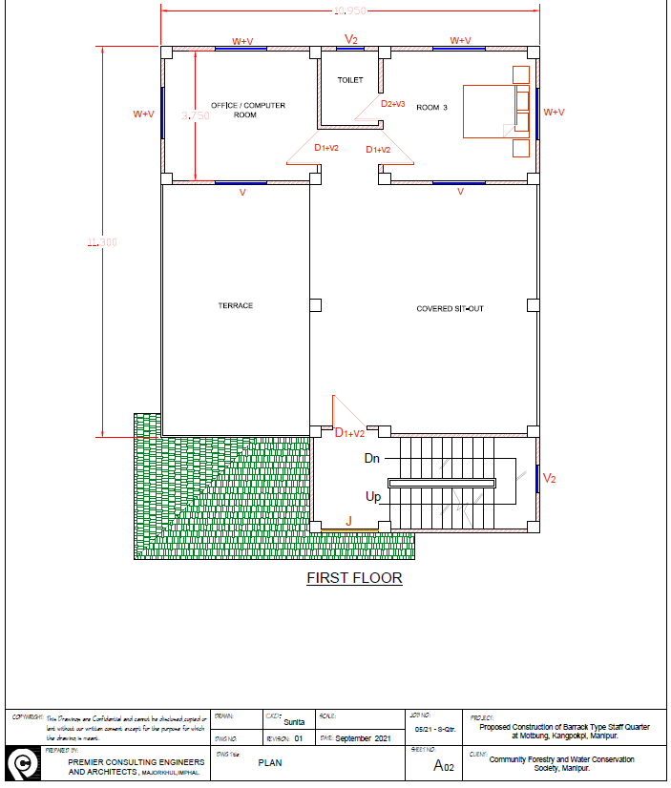

FIRST FLOOR PLAN

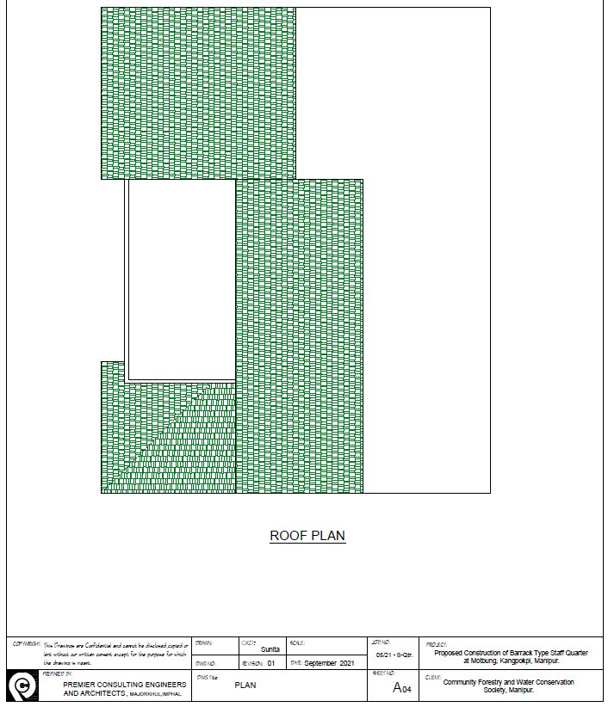

ROOF PLAN

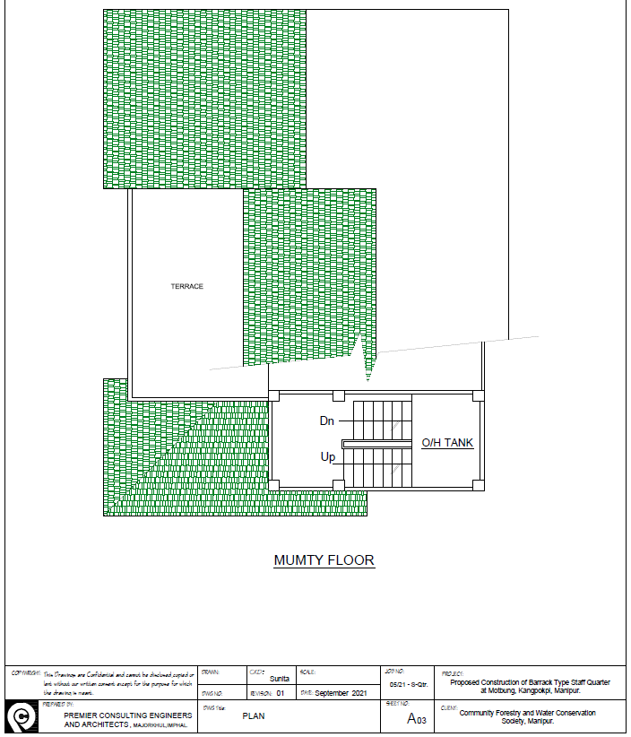

MUMTY FLOOR PLAN

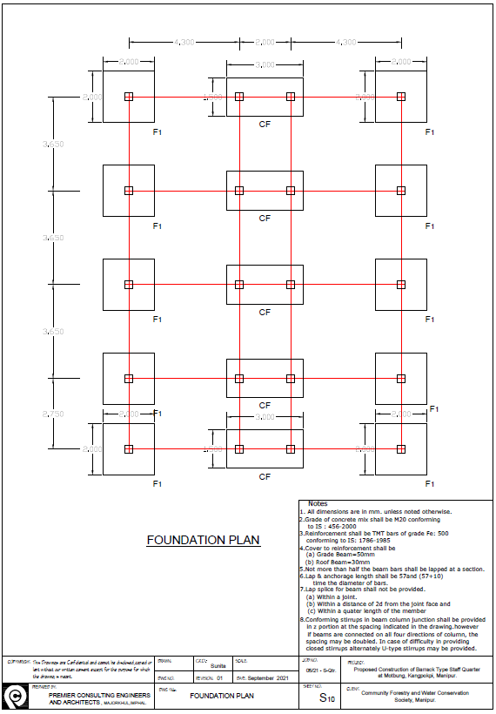

FOUNDATION PLAN

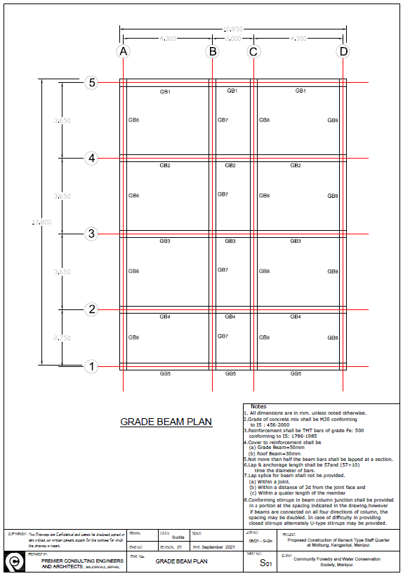

GRADE BEAM PLAN